Operating Instruction for OTDR FHO5000-S20

Firstly, install the PC software.
Double-click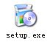, follow the prompts to install.
After successful installation, double-click 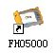 on the desktop to start the PC software.

The main interface is shown below:
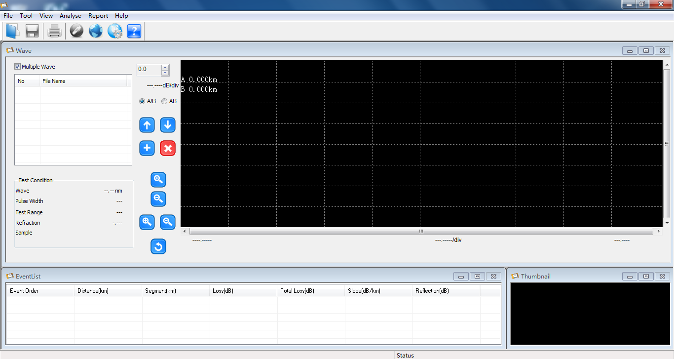
Figure 1-1

Secondly, the instruction to use PC software.

- Select the menu "File" -> "Open File" to browse curve data that needs to be opened. It’s shown in Figure 2-1 and Figure 2-2
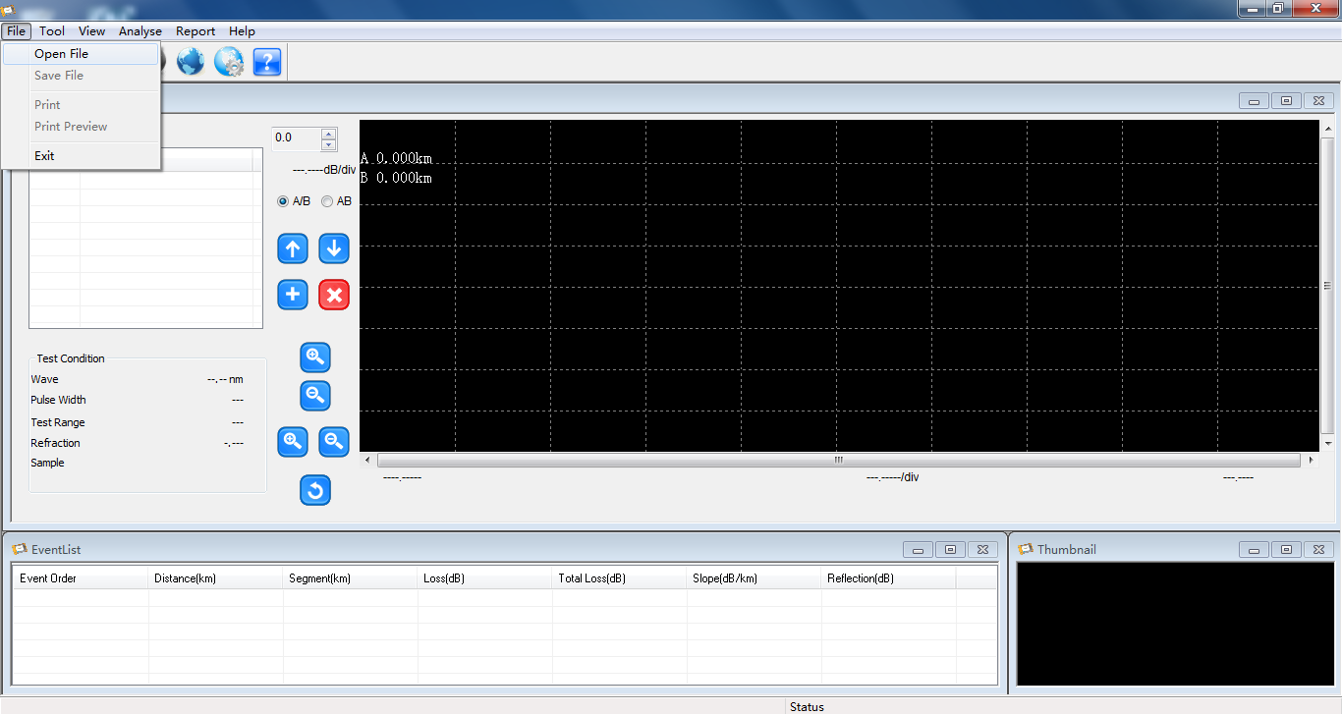
Figure 2-1

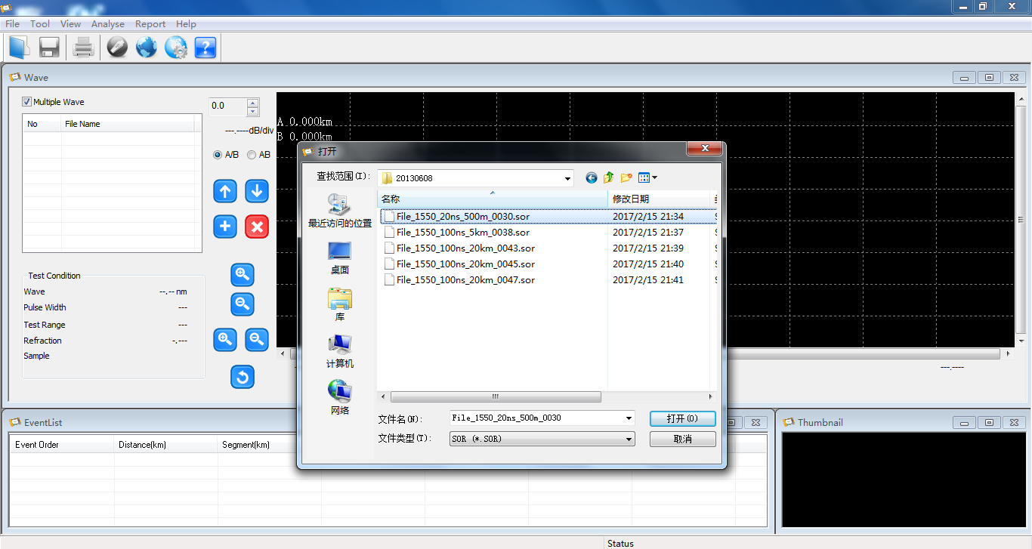
Figure 2-2

Open the .sor file. It’s shown in Figure 2-3
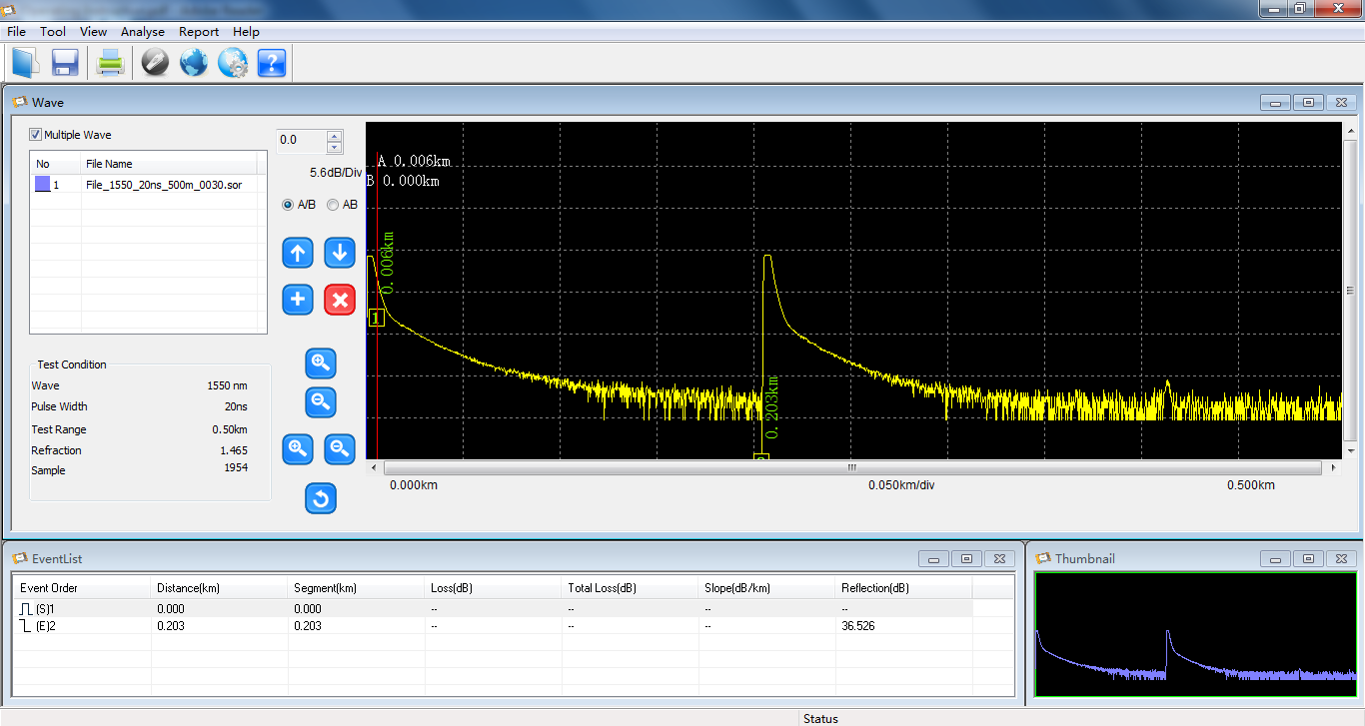
Figure 2-3

2. After opening curve, select the menu "File" -> "Print Preview" or "Print", you can print preview or the curve directly. It’s shown in Figure 2-4
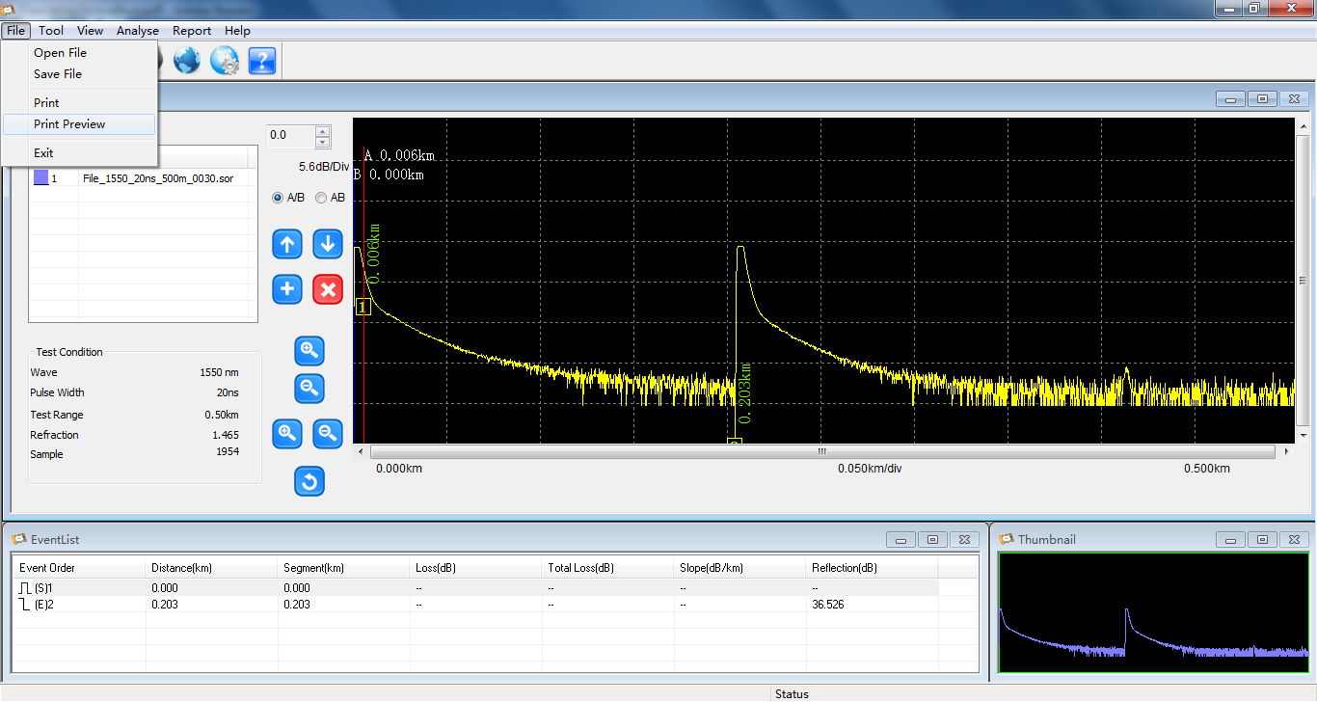
Figure 2-4

- Select the menu "Tool" -> "Remote Connect", OTDR instrument will be synchronized with the PC software for remote operation. It’s shown in Figure 2-5 and Figure 2-6
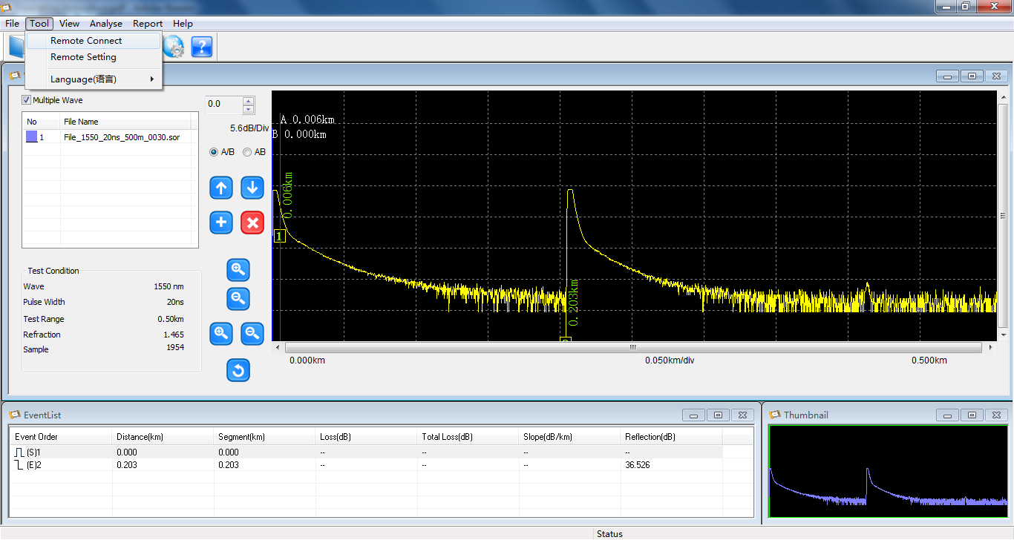
Figure 2-5
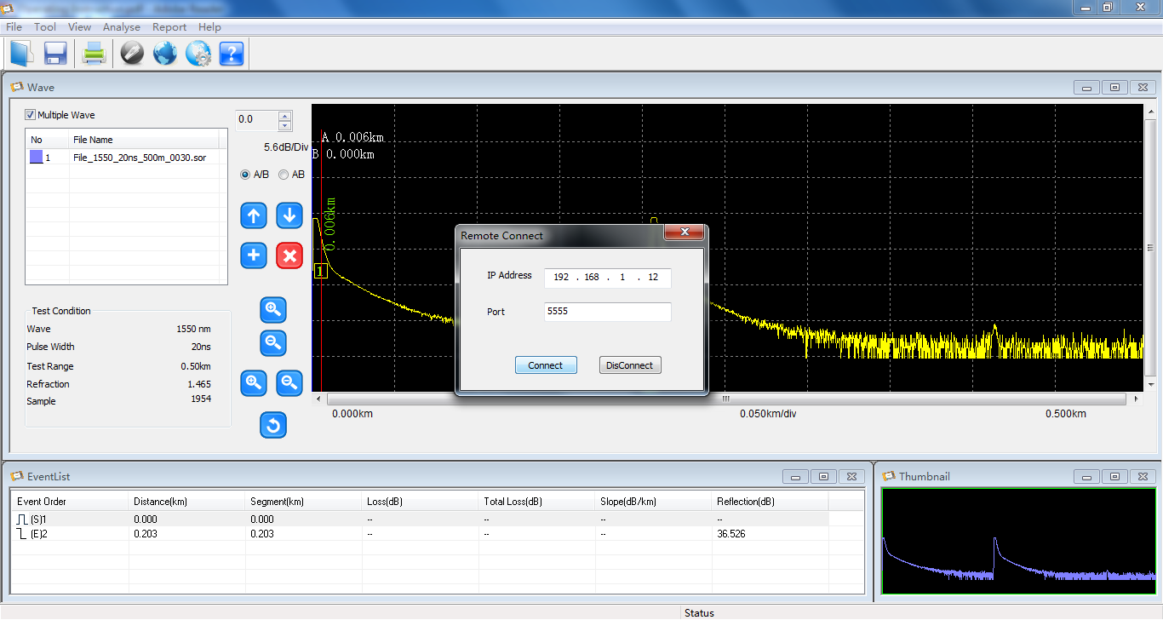
Figure 2-6

4. Select the menu "Tool" -> "Remote Setting" for remote control settings. It’s shown in Figure 2-7 and Figure 2-8
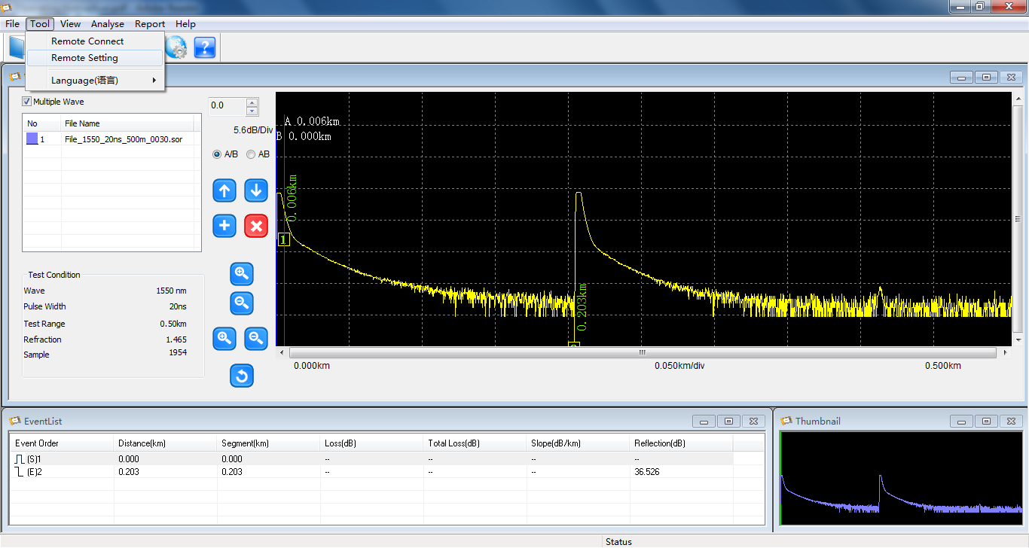
Figure 2-7
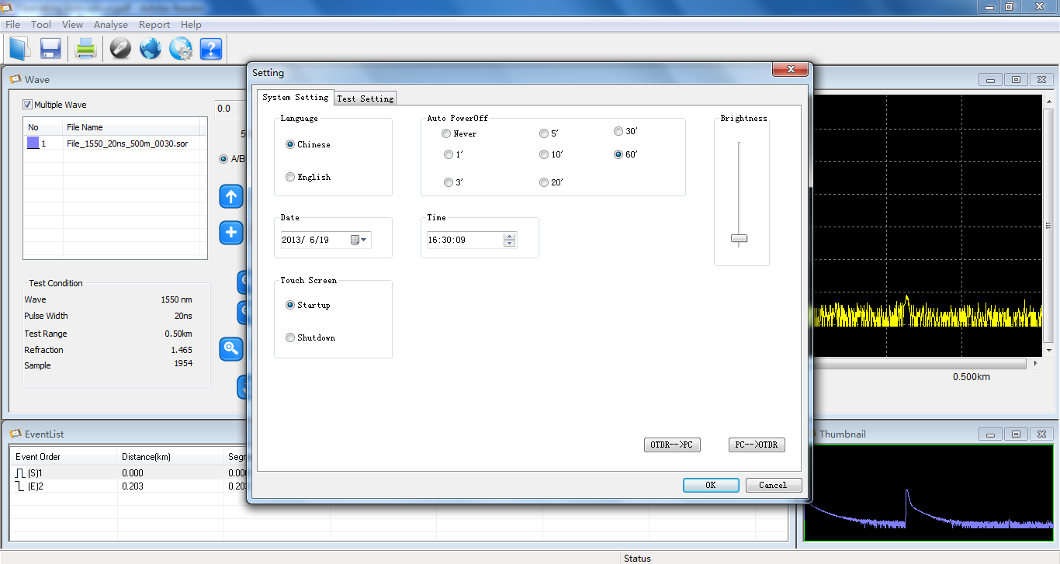
Figure 2-8

5. Select the menu "View" -> "Wave Screen Setting". The curve can be set up, such as the choice of colors and other attributes. It’s shown in Figure 2-9 and Figure 2-10 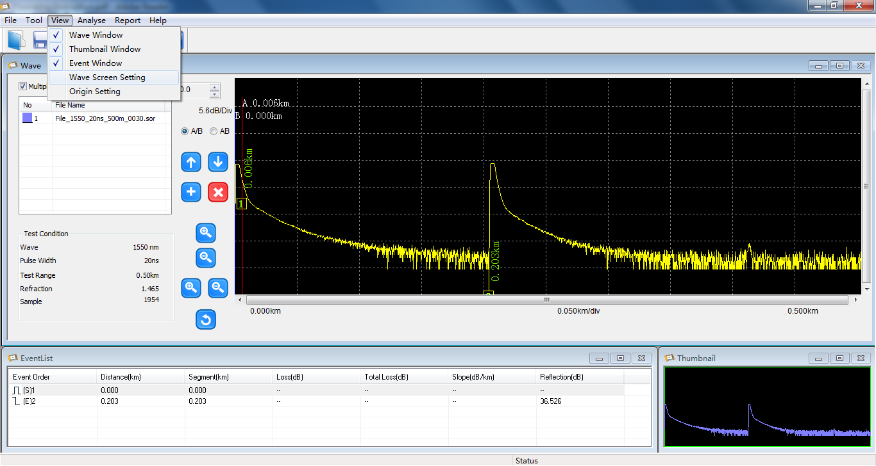
Figure 2-9
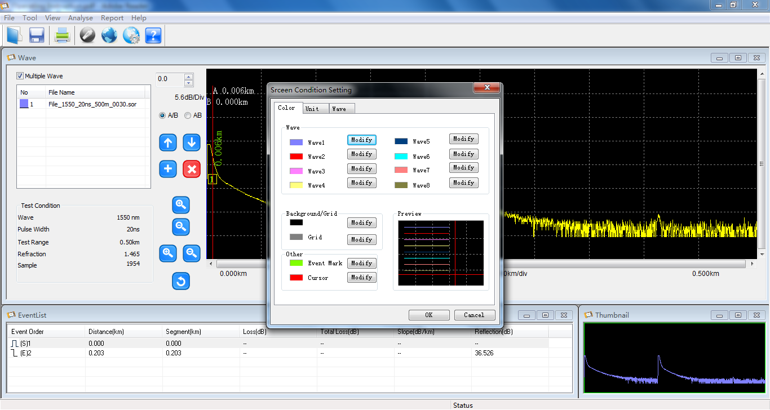
Figure 2-10
6. Select the menu "Report" -> "Report Wizard" , you can export Excel file format of the curve data, the operation is shown in Figure 2-11 to Figure 2-19
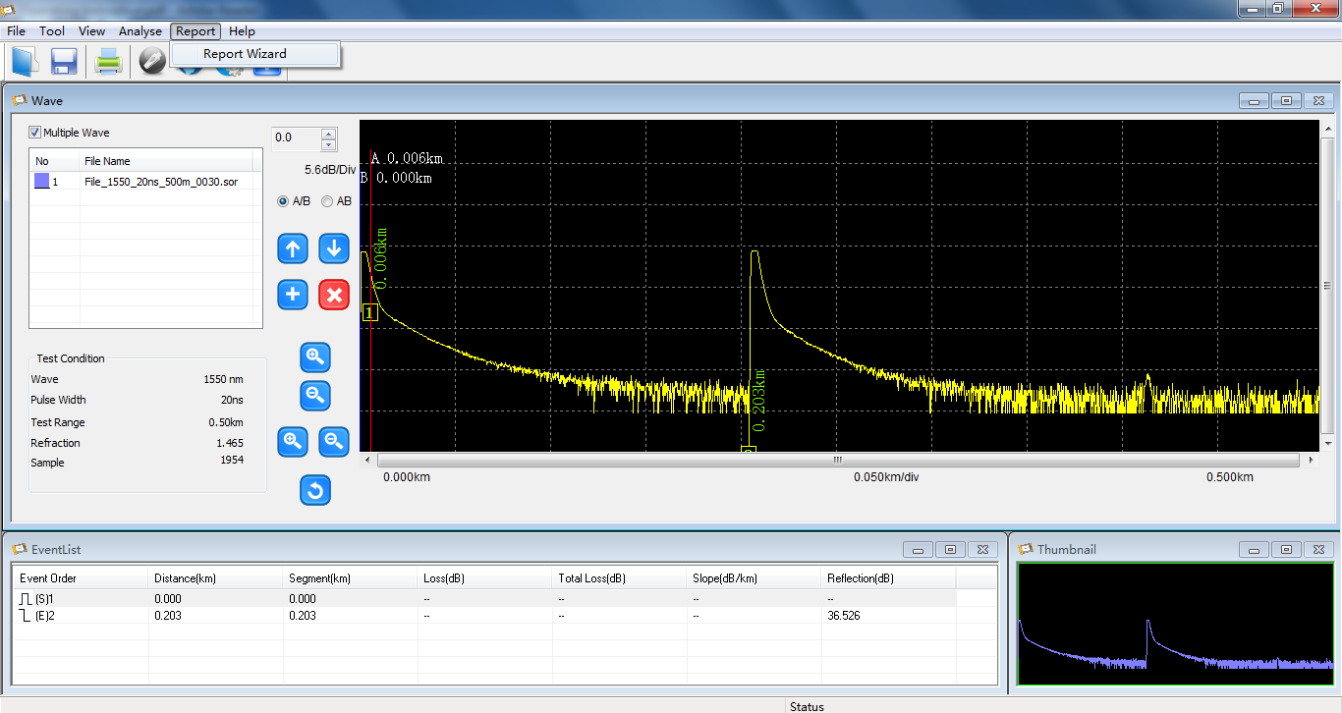
Figure 2-11
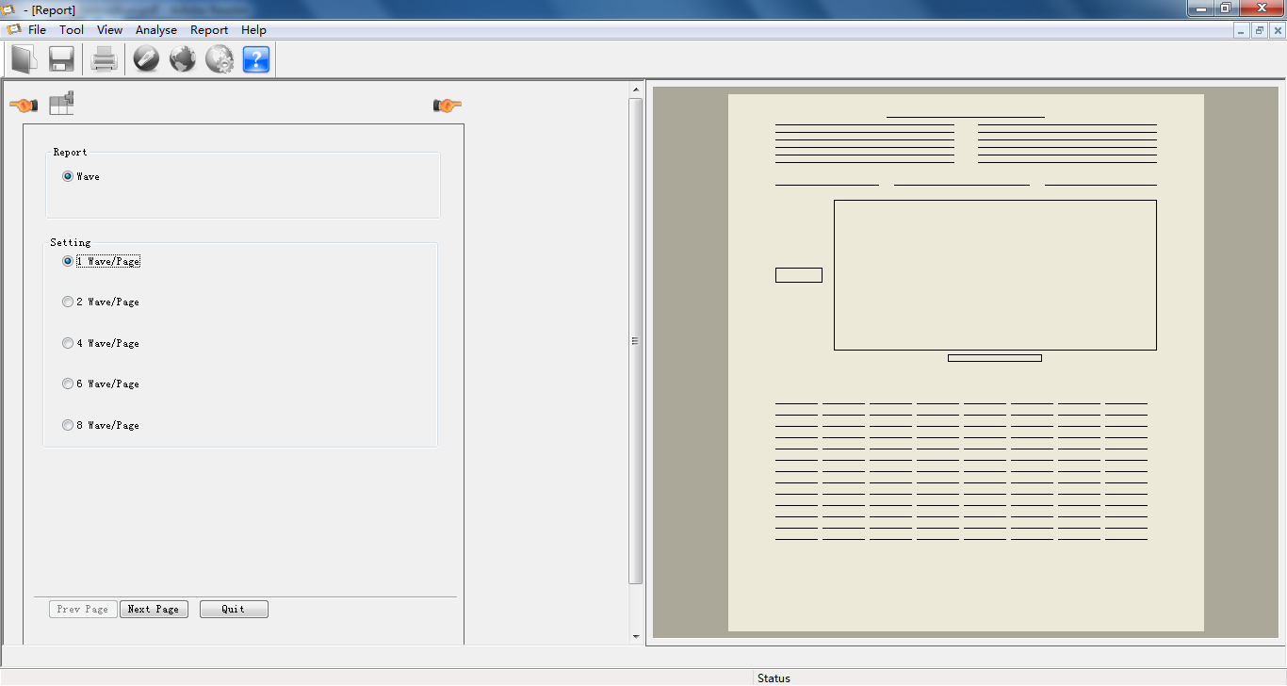
Figure 2-12
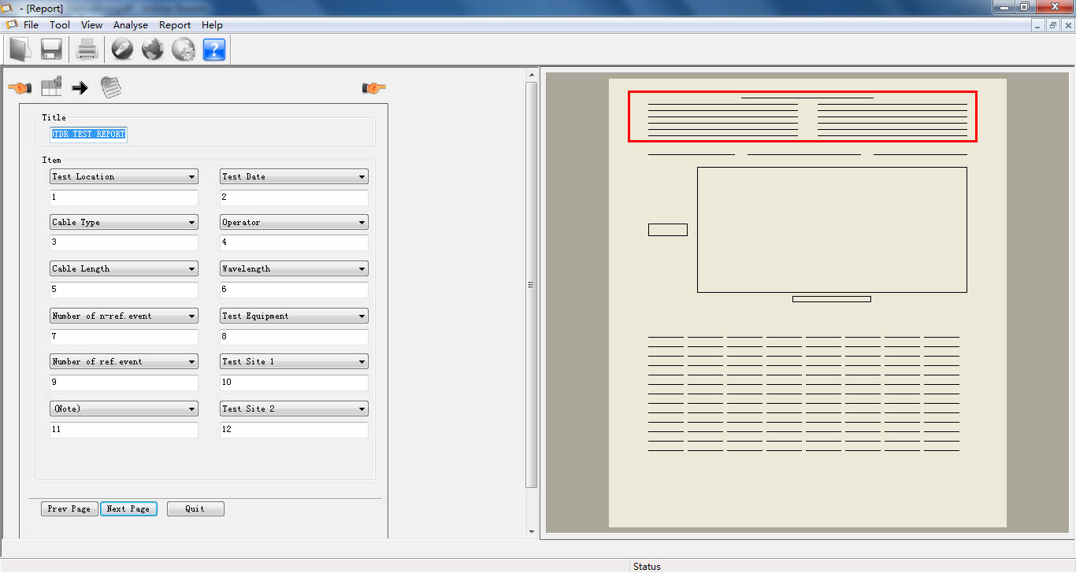
Figure 2-13
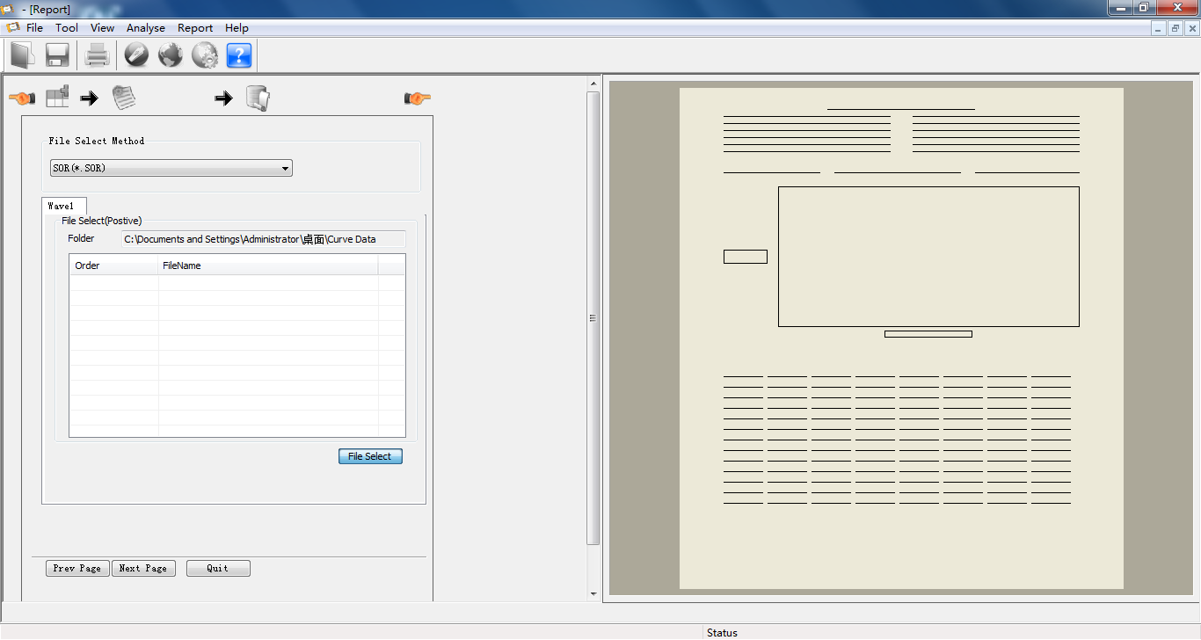
Figure 2-14
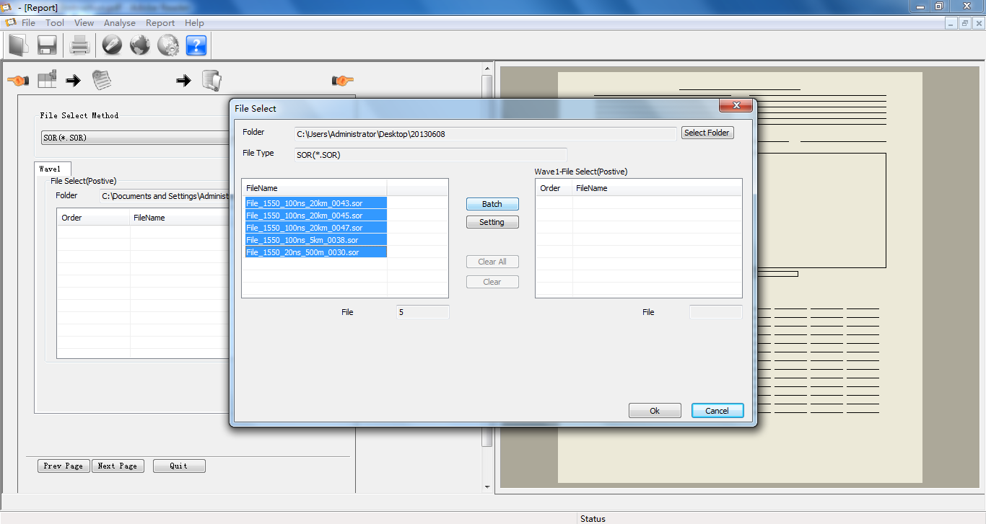
Figure 2-15
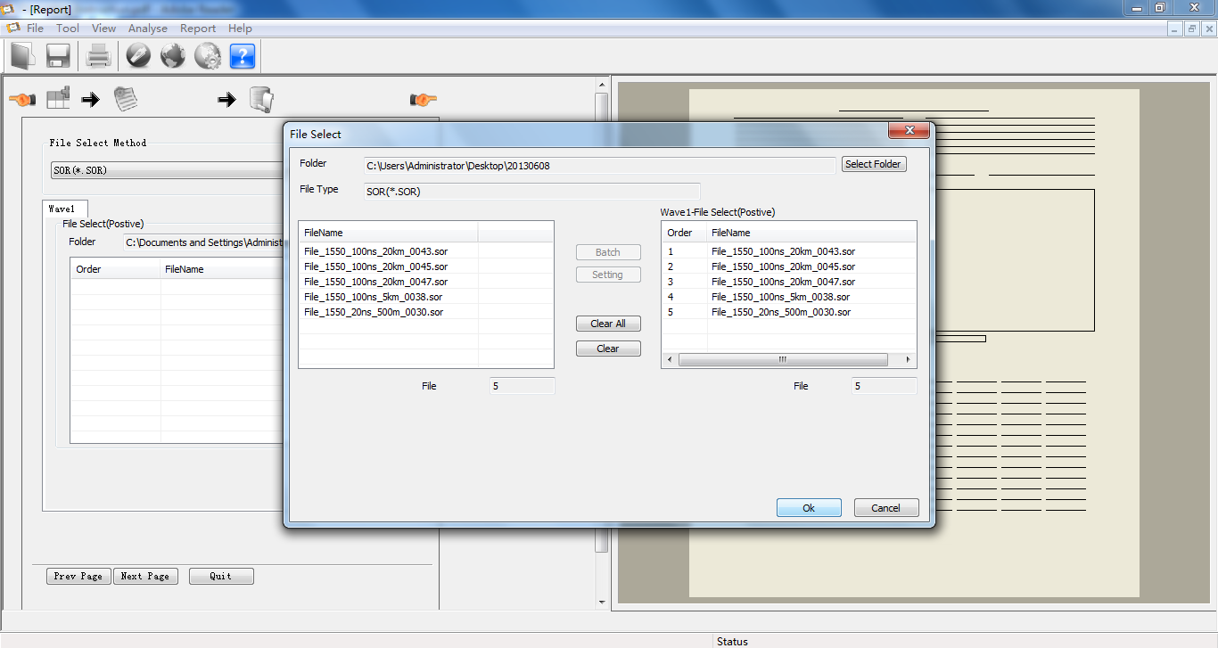
Figure 2-16
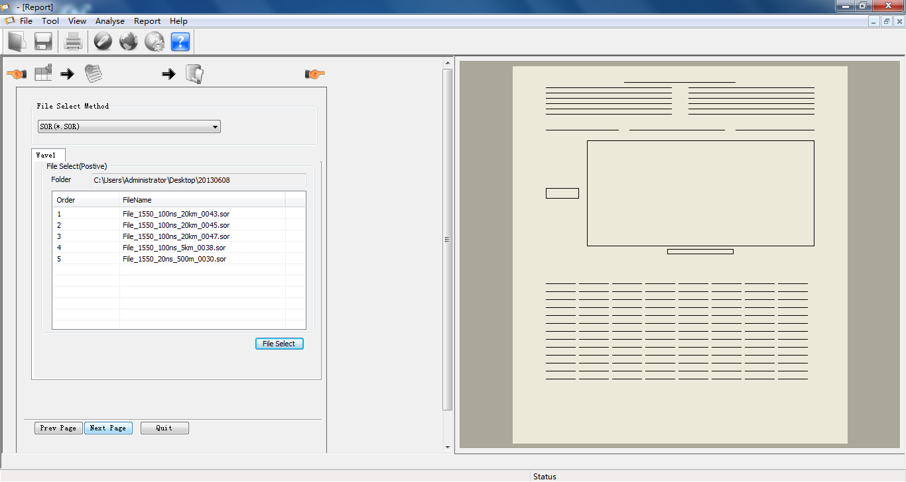
Figure 2-17
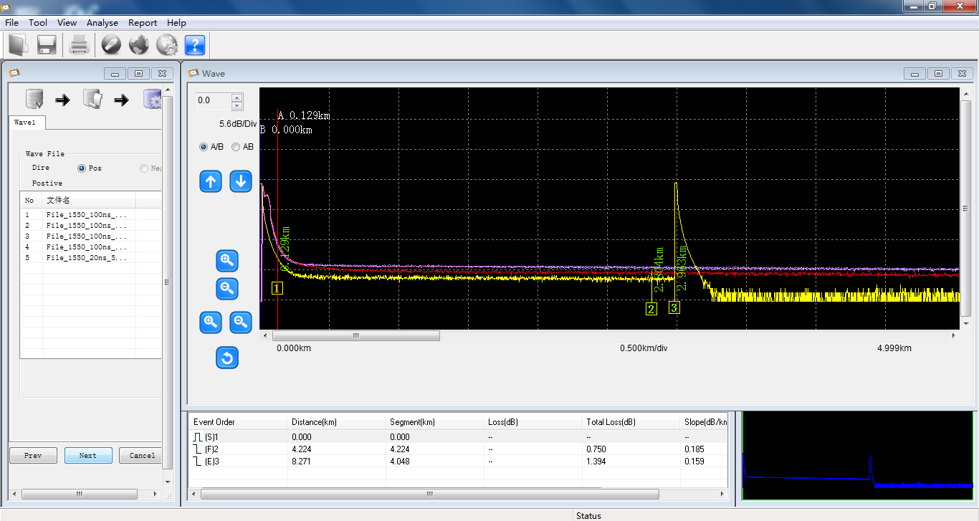
Figure 2-18
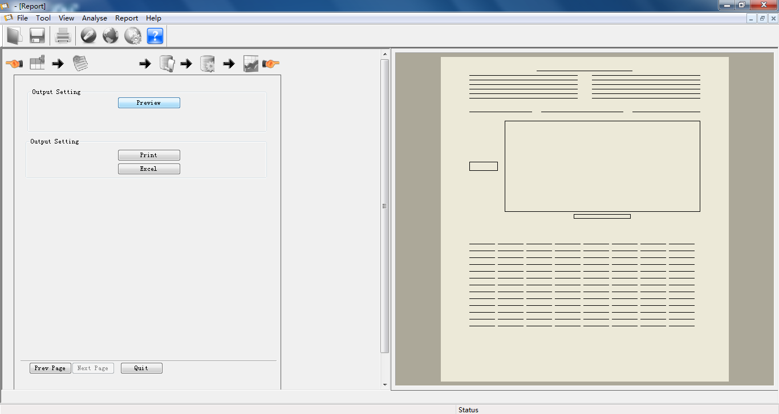
Figure 2-19

Thirdly, uninstall the software.
Select “Start” -> “All Programs” -> “FHO5000” -> “Uninstall.exe”, click “Uninstall.exe” to uninstall the software.

